ENSO GROUP

01M
Information and Schedule

15th September 2018- 22nd September 2018

Your main contacts in Málaga:

1. Any emergency, please contact Rose Bennett: 0044 (0) 7568345359; if you don’t speak any English: Martyna Mista: 0034 612 20 36 91 (Polish, English and Spanish)

2. Your guide for some excursions is Magda: 0034 632 469 392

3. Your project coordinator: Soledad: 0044 (0)79 10 72 8853 – soledad@ensoeu.com In case Soledad is not available, please contact Rose Bennet: 0044 (0) 7568345359 – rose@ensoeu.com

Emergency Contacts:
Police, ambulance, fire: 112
Tourist Medical Service: 061
More information at: http://www.juntadeandalucia.es/temas/salud/urgencias/urgencias.html

Accommodation

Accommodation is on a basis. Option 1 and Option 2. See Attachments.

Address Option 1: Avenida de la Estación de El Palo nº 5. 29018 Málaga
Address Option 2: Avenida Salvador Allende nº 11

Map Between accommodations:

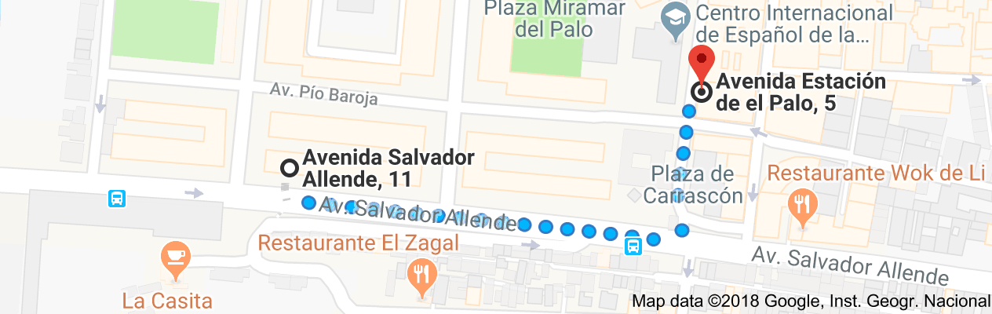

Map to city center:

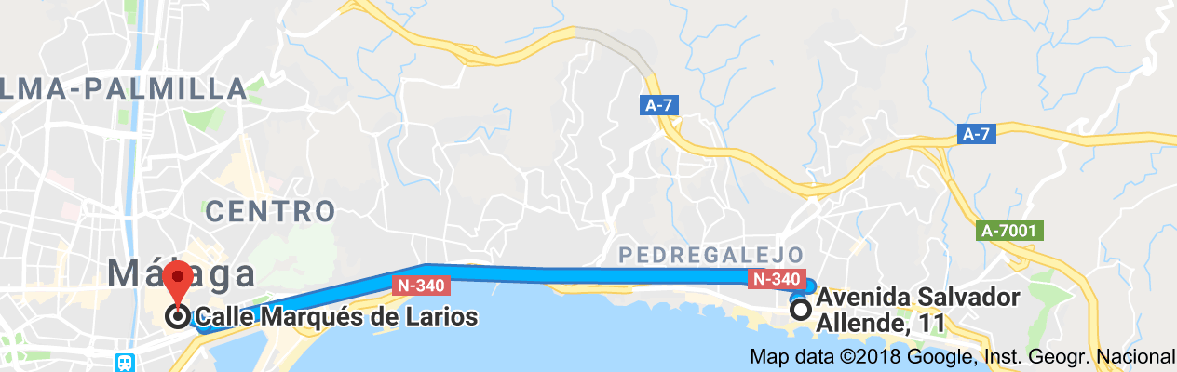

WEEKLY SCHEDULE PLANNER

Schedule - TRAINING will be conducted in English only.
Meetings will be translated from Spanish to Polish.

ITINERARY
Date | Schedule
Saturday 15th September | Sat 15 Sep 11:30 - 15:25 FR 4060  Warsaw Modlin to Malaga  Arrive Malaga 15.25. Greeted by Magda Czaja.  Transfer to Accommodation.  Free Time  Beach Walk meet- Self Guided.  Events on of Interest  Suggested for personal interest in your own time  Fashion week  World masters athletics
Sunday 16th September | Free Day - Self Guided
Monday 17th of September | Gibraltar Trip and Welcome Meeting  Meet Rose at Day Excursion. Meeting Point at 6.40: Av. de Andalucía, 8, 29007 25 minutes away from host family.  Day trip to Gibraltar  Bus leaves at 6.55 am and arrive to Gibraltar around 10.00 am. You will visit the top of Europe, entrance to the San Miguel cave and the possibility to see the famous monkeys of Gibraltar up close. The visit lasts approximately 1.5 hours. Then, you will have 3 hours of free time to make purchases and visit the city on their own. YOU MUST BRING YOUR PASSPORT FOR BORDER CONTROL UPON GIBRALTAR ARRIVAL (without a passport you cannot enter Gibraltar)  During trip we will cover awareness and cultural intelligence - presentation  Culture - values, norms and attitudes
Tuesday 18th of September | Asociación Arrabal  Address: Calle Dos Aceras 23-25. 29012 Málaga  Phone: 0034 952 30 05 00  Contact person: Mr. Juan de Lucas  Meet Martyna and Rose 09.00 Cafe Central (Plaza de la Constitución, 11, 29005 Málaga, España)  09.30 - Welcome by José Antonio Naveros, President of Arrabal-AID and Laura López, director of the center of Málaga.  10.00 - 10.30 Francisco Javier García, Employment Technician SAE program.  Topics: process, job search, attention, online management, documents, insertion, bonuses, guarantee, times.  10.30 - 11.15 María José Álvarez, Employment Technician Incorpora Program:  The Incorpora Method has become a benchmark in the work integration of people at risk of exclusion. https://www.incorpora.org/metodoincorpora  Topics: intermediation, certificates, training  11.15-11.45 Josefa Reyes/Mónica Palomino, technical activities and support programs for work insertion of people deprived of freedom and on probation.  Topics: inclusion, social and labor reincorporation, employment  11.45 - 12.15 Break  12.15-13.30 Álvaro García, E2O second chance school technician, is included in the Youth Guarantee Implementation Plan in Spain, among measures to improve employability and increase job opportunities for unemployed young people who dropped out at an early age. Practical case Young people arrived in small boats, situation illegality.  Topics: youth, illegal immigration, minors, employment.  14.00 -15.30 Cafe Central with Rose  Overview of programme objectives/goals.  Resolution of conflicts and negotiations between representatives of different cultures.  Work in couples to produce presentations for colleagues in Poland re lessons learnt / project so far.  16.00 - 17.30 Training & gaining practical skills Asociación Arrabal with Magda Czaja  Self-employment, program for the creation of your own job.  Topics: grants, entrepreneurial profile, methodology, procedures, difficulties.  18.00 - 19.00 Shopping and free time
Wednesday 19th of September | Meet Rose and Martyna at 0930 Cafe Central (Plaza de la Constitución, 11, 29005 Málaga, España)  10.00 - 11.30 am Visit at local Jobcentre in Malaga  Address: Av. Juan XXIII, 82 29006 Málaga  Phone number: 0034 600168708  talk about “Developing initiative and entrepreneurship in working with foreigners”. The importance of developing a culture of coaching in job centres - a programme exclusively designed with a job centre environment in mind. TBC  Contact Person: Carlos Palomo  Consejero Eures de Málaga  Delegación Provincial del SAE  12.00-13.00 am Visit Job Centre  Avenida del Doctor Manuel Domínguez, Calle Kandinsky, 26, 29010 Málaga, España  Phone:+34 955 62 56 95  Contact Person: Carlos Palomo *  Cafe Central with Rose (Plaza de la Constitución, 11, 29005 Málaga, España)  13.30 - 15.30 Creativity workshops “We Are Not Job-Seekers, We Are Job-Creators”— Turning Unemployment into Entrepreneurship”  Work in pairs -preparing case studies  15.30 - 17.00 Creativity workshops continuation -  Presenting cases - competition time!
Thursday 20th of September | Meet Rose and Martyna at 0930 Cafe Central (Plaza de la Constitución, 11, 29005 Málaga, España)  10.00 - 11.30 Visit to Malaga Acoge  Address: Calle Ollerías 15. 29012 Málaga  Phone: 0034 952 22 64 64  Contact person: Mrs. Irene Peñalver  “How we help migrants in their search for employment through a comprehensive itinerary”  12.00-13.00 visit Cámara de Comercio de Málaga  Address: C/ Cortina del Muelle, 23, 29015 Málaga, España  Phone: +34 952 21 16 73  Contact Person: Maricruz Molina  Director of the Department of Employment of the Chamber of Commerce of Malaga  "Methods of job search. Promotion of the culture of entrepreneurship"  Cafe Central with Rose (Plaza de la Constitución, 11, 29005 Málaga, España)  13.30 - 14.00 Creativity workshops with  Coaching and Mentoring (What is coaching? And what’s the difference between mentoring and coaching? Empowering others in the everyday situation:  -“Intercultural communication. Culture, values, norms and attitudes.  -A intercultural communication skills  14.00 - 15.00 Seeking for tools for testing entrepreneurial competences among foreigners in order to identify available opportunities for personal, professional or business activity  15.00 - 17.00 Using found tools - creating scenarios in pairs and role plays. Opportunities to develop practical skills vrs. Creative approach (not in pairs)  17.00 - free time  Suggestion  In Muelle Uno, there is still a lot of summer laden with rhythm from the hand of Málaga Swing , we are going to enjoy THURSDAYS ARE A SWING!  On Thursday, September 20, One Two Swing, live music and a lot of dancing, at 9:30 p.m. at the Artsenal .  http://www.muelleuno.com/eventos/los-jueves-sona-swing/
Friday 21th of September | Meet Rose and Martyna at 0930 Cafe Central (Plaza de la Constitución, 11, 29005 Málaga, España)  10.00 - 11.30 Visit to Asociación Marroquí para la Integración de los Inmigrantes  Address: Calle Jinetes 5. 29012 Málaga  Phone:0034 952 21 89 87  Contact person: Mrs. Alba  Talk by Alba about “Role of social workers in the integration and search for employment of disadvantaged sectors. Multicultural society. Different points of view. Open to the world.”.  Cafe Central with Rose (Plaza de la Constitución, 11, 29005 Málaga, España)  12.30 - 17.00  Development of best practices and business plans for job centers. How information learned over project can be best implemented.  17.00 Farewell Presentation
Saturday 22th of September | Transfer from accommodation to airport 0430  Malaga to Warsaw Modlin  Sat 22 Sep 07:10 - 11:05 FR 4059

Whats on in Malaga during your stay

Modern Utopias Collection. Centre Pompidou
The Centre Pompidou Málaga launches a cycle dedicated to addressing each of the sections into which the semi-permanent Modern Utopias exhibition is divided.
These screenings will take place every Sunday, from March to November, 17:00 to 20:00 in the centre's auditorium. These films, videos and documentaries from the Centre Pompidou collection reflect the influence of the philosophical concept of utopia on the lives of creators, artists and different personalities of life in general during the last century.
According to its theme, this exhibition is divided into six major sections: The Great Utopia, The End of illusions, Together, The Radiant City, Imagine the future and The Golden Age.
The pieces selected in each of these sections reflect the historical events that have marked the current time and that have nourished the imagination and ideals of modern and contemporary artists.
http://www.centrepompidou-malaga.eu

15th Edition of the Municipal Flamenco Classroom. María Victoria Atencia Cultural Centre
This new edition of the Municipal Flamenco Classroom will be held at the MVA centre in Málaga. It will includes eight performances that will show flamenco art in song, touch and dance with artists from Málaga.The spirit of the flamenco classroom and the reason it was created was to promote the richness of the flamenco art that Málaga and its province treasure. Don't forget that the province is an important part of the origins of flamenco art.These aspects must be highlighted and the fifteen editions of Municipal Flamenco Classroom in Málaga already held must be celebrated. Once again to promote flamenco art and the artists of the land. Fortunately, Málaga has many flamenco artists of great quality in singing, dance and playing the guitar.
Sea Sorrow 20th September 20.30 Free Performance (Limited Seating)
'Sea Sorrow' represents Vanessa Redgrave's debut as a film director, and it is a very personal and dynamic reflection on the current world refugee crisis, through the eyes and voices of militants and children, who mix The past and the present. The documentary is a reflection on the importance of the rights of the human being.
Centro Cultural MVA. Calle Ollerías 34, 29012 Málaga
http://www.centroculturalmva.es/6868/com1_fb-0/com1_md3_cd-24141/

Malaga’s central market dates back to the 14th century. It was originally built by the Moors as a shipbuilder's yard and the Arabic name “Atarazanas” can be loosely translated as such. With its fascinating history, the market has an enchanting atmosphere and is a great place to go shopping for all kinds of local produce including olives, oils, fish, seasonal fruit and vegetables. For a more detailed overview of the products for sale at the market, have a read of our best stalls in Malaga’s Atarazanas Market article. It’s open from Monday to Saturday (closed on Sundays) from 8:00am until 14:00pm
The Pompidou Centre is both an art museum and art gallery split into three parts - a museum, a temporary exhibition space and a children’s workshop area. Collections include photography, design, architecture and video and there are exhibitions of creative arts such as dance, film and spoken word. Entry is free between 16:00pm and 20:00pm on Sundays.
The Carmen-Thyssen Museum exhibits a collection of 230 works of 19th century Andalusian painters. Entrance is free every Sunday from 17:00pm to 20:00pm.
Malaga’s Centre of Contemporary Art (known as CAC) houses a fantastic collection of 20th and 21st century art. Featuring artists such as Demian Hirst, Louise Bourgeois, Olafur Eliasson as well as a number of Andalusian artists. The museum promises not to disappoint and entry is free.
Museo de Malaga
This 18,000 square metre museum has eight rooms - five dedicated to archaeology with a collection of over 15,000 pieces and three dedicated to fine arts with a collection of over 2,000 pieces. It reopened recently in December 2016 and admission is free.
The Alcazaba fortress and Gibralfaro castle are two of Malaga’s most breathtaking landmarks and are both unmissable attractions for anybody visiting the city.
A walk through the eucalyptus trees and carefully landscaped gardens is a truly enchanting experience and the views from the castle are quite simply the best Malaga has to offer.
Entrance to both the Alcazaba and the Gibralfaro castle are free after 14:00pm on Sundays.
The Gibralfaro hill has two of the best viewpoints in the whole city. One is located on the side of the Gibralfaro hill, between the gardens and the castle and the other is located right on top of the hill next to the castle, which you can access by car if you don’t fancy walking.
The Montes de Malaga are the city’s green lungs, located just a few kilometres outside the centre it really feels like you are a world away from the hustle and bustle of the city.
The nature park has numerous hiking trails, picnic spots and traditional restaurants where you can try one of the popular local dishes ‘plato de los montes’ or ‘dish of the mountains’.

If you choose to walk to the viewpoints, bare in mind that the ascent is very steep and depending on how fast you walk, it can take between 20 - 45 minutes. A nice idea is to carry some drinks and snacks with you and when you get to the viewpoint, sit down, have a rest, soak up the relaxing atmosphere and enjoy the fantastic city and sunset views on offer.

